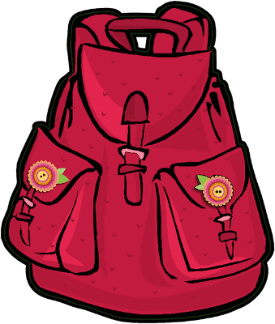
Organisational skills

- Set a regular time to help your child organise their school bag. Support with throwing away and sorting!
- Get them to pack their school bag the night before – together with any extra items needed e.g. PE kit, Art kit.
- Use a clear pencil case. This way it is easy to see what is inside and what might be missing.
- Use plastic pockets and plastic envelopes for storing worksheets etc. These can be colour coded if it helps.
- Ensure a ready supply of stationery: pencils, pens, rubbers, hole punch, hole reinforcers, file dividers, stapler, ruler, calculator, dictionary (or electronic dictionary), Post-it notes, highlighters, scissors, glue stick, coloured pencils, index cards, note book etc. Although your child may lose some of these items from time to time, get them to identify what needs replacing on a regular basis. This way, you are encouraging them to take some responsibility.
- Have a specific box or bag for holding supplies for school things or extra-curricular activities. Keep it in the same place and emphasise the idea of using it daily.
- Consider creating a portable homework kit in a lightweight container. This way, no matter where your child chooses to study, they have everything they need.
- Ensure a clutter free work area. Help your child clear out drawers and shelves and decide what to keep or throw away.
- Provide your child with a notice board to displays letters, calendars etc. A ‘write on/wipe off’ surface is ideal for reminders and lists.
- Label any storage boxes, files, drawers etc..
- Encourage the use of post it notes for reminders. A small amount of these can fit under the front cover of the planner and are easily seen.
- Try colour co-ordinating by subject. For example, green for History, blue for Geography etc..
- Display copies of the school timetable in prominent places.
- Get your child to make a daily checklist of the items that need to be brought into school. Some items are always needed but some will depend on the day of the week. Put this up on a noticeboard

